ESS: Chapter 8: Early Earth: student notes: Prater

LT1: I can describe how the earth formed.

- It is theorized that Earth formed approximately the same time as the Sun and other planets in the Solar system.
- Combination of the collision of gas and solid particles led to a large mass called planetesimals.
- Further combination of planetesimals formed the planets.
- Earth must be at least as old as the oldest rock in the crust.

How Old is the Earth???
https://www.youtube.com/watch?v=5yFnO2O6XPM

The following evidence confirm for scientists that the age of the Earth is 4.6 billion years
From Radiometric dating:
1) age of the oldest rock on Earth is between 3.8 to 3.9 billion years.
2) Zircon grains in the sedimentary rocks are between 4.1 to 4.2 billion years old.
3) Meteorites between 4.5 to 4.7 billion years
4) Oldest rock from the Moon collected from the Apollo mission: 4.6 billion years

Earth was most likely extremely hot shortly after it formed.
The three sources for this heat are:

1) Abundance of radioactive isotopes and its decay over time produced energy in the form of heat.
2) Impact of asteroids and meteorites on Earth created tremendous amount of thermal energy. Asteroids are metallic or silica rich objects that are 1km to 95 km in diameter. Meteoroids are small asteroids or fragments of asteroids. When meteoroids fall to Earth it is called as meteorites.
3) Due to gravitational contraction. Increase in size of the Earth due to meteor bombardment and subsequent accumulation of meteor material on Earth. Weight of material caused gravitational contraction of the underlying zones. Energy of the contraction was converted to thermal energy. New material caused blanketing effect prevented generated heat from escaping.

- Combination of the three sources made a hot and rather inhospitable beginning of Earth.
- Cooling and subsequent crystallization laid the foundation of Earth’s crust to form and prepare Earth for the next phase in its development.

LT2: I can describe the divisions of geologic time.

Geological Time Scale
Scientists interpret Earth’s fossil record and geological events by use of a chronologically sequenced chart called geological time scale.

This scale represents Earth’s history from its formation 4.6 billion years ago to the present.

It is designed so that the oldest divisions are at the bottom of the chart with each division above being successfully younger.

Eons, eras, periods and epochs are the division of time utilized on the chart by geologists worldwide.
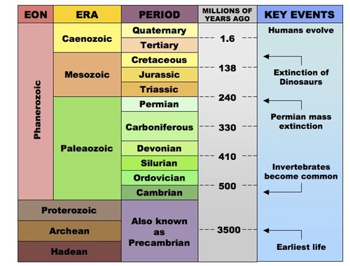
Eon – longest time unit.
Measured in billions of years. The Archean, The Proterozoic and The Phanerozoic are eons.

Era – Next longest span of time.
Measured in hundreds of millions to billions of years.
Defined by the differences in life-forms found in rocks.
Names are based on the relative ages of the life forms.
In Greek: plaeo – old; meso – middle; ceno – recent; Zoic – of life; Mesozoic – middle life.

Periods: life forms that were abundant or became extinct during the time in which specific rocks were deposited.
Measured in tens of millions of years to hundreds of millions of years.
Names for the geographic region in the rocks of that age were first observed, studied and described.
Mississippian period – distinctive lime stone bluffs along the Mississippi river.
Jurassic period – named for the rocks were described in the Jura Mountain in Europe.

Epochs: smaller division of geological time scale usually measured in million of years to tens of millions of years.
Fossil record of the Cenozoic Era is relatively completed due to less time for weathering and erosion to remove evidence of this part of Earth’s history.

LT3: I CAN describe relative dating techniques of rock layers

Dating of Rocks: Relative Age

- Earth was about 6000 years old – majority of the world believed at the turn of 19th century.
- Determined by Archbishop James Ussher of Ireland – used a chronology of human and Earth history to inaccurately calculate Earth’s age.
- James Hutton: in 1770: observed and attempted to explain the forces that continually change the surface features of Earth using the principle of Uniformitarianism.
Those changes are mountain building, erosion, earthquakes and sea level changes.
Principle of Uniformitarianism: States that the process occurring today have been occurring since Earth formed. Example: Ocean waves eroding sand from a beach is NOT a new process Only the rate, intensity, and scale with which they occur have changed.

Principles for Determining Relative Age:

- Relative age of geologic event, rock or fossil can be determined by comparing it to other events, rocks or fossils.
- Three primary geological principles are used by geologists to determine the relative age of an object or event.

They are principle of original horizontality, principle of superposition and the principle of cross-cutting relationships.

Sedimentary rocks:
Sedimentary rocks are pieces of solid materials (sediments) become cemented together.
Most of these rocks were originally deposited millions of years ago by water and wind. Layers of rocks can be assumed as that the oldest rocks are at the bottom and each successive layer going toward the top is younger.

- Principle of original horizontality states that sedimentary rocks are deposited in horizontal or nearly horizontal layers Example: Walls of Grand Canyon
- Principal of Superposition states in an undisturbed rock sequence, the oldest rocks are at the bottom and each successive layer is younger than the layer beneath
- Principle of cross-cutting relationships states that an intrusion or fault is younger than the rock it cut across. Example: granite (igneous rock) is younger than the Schist (metamorphic rock), because granite cut (melted) across the schist.
A Fault is a fracture in Earth along which movement takes place. A fault is younger than the strata (layers) and surrounding geological features because it cuts across them

- Inclusions: Relative age can also determine when an overlying rock layer contains particles of rock material from the layer beneath it.
- The bottom layers were eroded and the loose material on the surface became incorporated in the newly deposited top layer.
- These particles called inclusions. They indicate that the rocks in the lower layer are older than those on the top.

Other means of determining relative age:

Unconformity: Erosion surface might become buried by the deposition of younger rocks. This buried erosional surface result in a gap in the rock record and is called an unconformity.

Disconformity: When horizontal sedimentary rocks overlie horizontal sedimentary rocks, the unconformity is called disconformity.

Nonconformity: Contact point between non-sedimentary and sedimentary rock is called nonconformity.

Correlation: It is the matching of outcrops of one geographic region to another. This information can be used to help in the exploration of oil or valuable minerals.

LT4: I CAN explain the concept of half-life with respect to fission and radioactive decay in Earth’s crust and how radiometric dating is used to obtain the earth’s age.

Absolute-Age Dating of Rocks:

Relative age dating – method of comparing past geological events based on the observed order of strata in a rock record.

Absolute age dating – Scientists to determine the actual age of a rock, fossil or other objects.
- Method for dating very old objects – Scientists used the decay rate of radioactive isotopes.
- The isotopes are found igneous and metamorphic rocks, some fossils and organic remains.
- Igneous rocks are formed from the crystallization of magma.
- Metamorphic rocks: Rocks formed due to combination of high temperature and pressure altering the texture, mineralogy or chemical composition without melting it.

Isotopes: These are atoms of the same element (carbon) that have different mass number (neutrons) and same atomic number (protons).

Ex: ^{12.01}₆C: ¹²₆C ¹³₆C ¹⁴₆C

- Easy way of identifying isotope of an element is to verify the mass number of the element in the periodic table. If it has decimal point then that element has an isotope.
- Out of 115 elements in the periodic table only 12 elements does not have isotopes (no decimal points in the mass number).
- The mass number of an element for an isotope is the average mass of all the isotopes of that element.

- Radioactive substances emit nuclear particles at a constant rate. As the number of protons and neutrons change with each nuclear emission, the element is converted to a different element.
- Original radioactive element is called the parent element and the new element is called the daughter element.
- Emission of radioactive particles and the resulting change into other elements over time is called radioactive decay.

The figure below illustrates the decay of radioactive isotope of Uranium -238 to isotope of lead – 206 over a specific span of time. (1/2 amount of Uranium 238 to Lead 206 is 4.5 billion years).

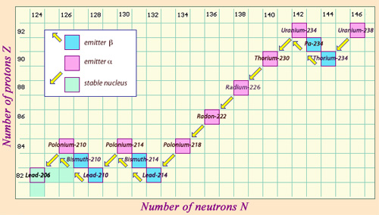
Radioactive decay – Spontaneous emission of radioactive particles and the resulting change into other elements over time. This rate remains constant regardless of environment, pressure, temperature or any other physical change.

Types of radioactive decay: Many different particles are produced during radioactive decay of nucleus. They are beta, alpha and gamma particles.
- Beta (β) particles: e represents an electron.
- Carbon 14 decays to Nitrogen 14 producing beta particles (electrons)
- C N + e

- Alpha (α) particles: He – helium nucleus.
- Radium decays to radon
- Ra He + Rn
- The above equation is called nuclear equation in which the mass number and atomic number are conserved.

- Gamma ray (γ) : It is a high energy photon of light having zero charge and zero mass number γ

Use of Radioactive Isotopes:
- Radiometric dating: Determination of the ratio of parent nuclei to daughter nuclei within a given sample of rock or fossil.
- This ratio used to determine the absolute age of the rock or fossil.
- As the number of parent atom decreases the number of daughter atom increases by the same amount and indicates the increasing age of the object.

Radioactive Decay of Carbon 14 to Nitrogen 14
 | % Parent Element | % Daughter Element | Elapsed years | Number of half lifes
Time 1 | 100 | 0 | 0 | 0
Time 2 | 50 | 50 | 5730 | 1
Time 3 | 25 | 75 | 11460 | 2
Time 4 | 12.5 | 87.5 | 17190 | 3

Half life: The time required for half of the original sample of nuclei to decay.
Below is a list of some common radioactive isotopes and their half lives.

Radioactive Isotope | Approximate Half life | Decay Product
Rubidium 87 | 48.6 billion years | Strontium 87
Thorium 232 | 14.0 billion years | Lead 208
Potassium 40 | 1.3 billion years | Argon 40
Uranium 238 | 4.5 billion years | Lead 206
Uranium 235 | 0.7 billion years | Lead 207
Carbon 14 | 530 years | Nitrogen 14

Other ways of Determine Age of object:
- Determining the relative or absolute age of an object or event is not limited to the use of rocks or chemical elements.
- Naturally occurring materials, such as trees, lake bottom sediments and volcanic ash are also used to determine the age of an object or event like forest fire, drought, flood or volcanic eruptions.
- Age of tree can be determined by counting the number of tree rings in cross section of the tree.
- In spring months – tree experiences greater growth
- In winter months – trees growth is less
- Width of the tree rings directly related to the climatic conditions during growth periods
- Dendrochronology – It is the science of comparing annual growth rings in trees to date events and changes in past environments.

