What is DNA?
- It’s a __________________________

- It is the chemical link between your genes and your traits.

- Chromosomes are made of ___________ which is made of ___________ which is a sequence of _____________________

- It’s an abbreviation for Deoxyribonucleic acid.

- It’s located in _______________________________.

- It was known to exist in the early 20th century but its structure not understood until the late 1950’s
- All living things use DNA( or RNA) as part of their _____________________________.

- Its general shape is a ________________________,which is 2 spirals held together with cross braces like a twisted ladder.

DNA’s structure

- As a chemical, DNA contains the same elements as other macromolecules: ____, ____, ____, and ____ It also contains P(phosphorus)
- DNA is made of ___________________(building blocks) called nucleotides.

- Each nucleotide is made up of 3 parts:

- a __________________ called ____________________

- 1 of 4 nitrogen-containing ___________ named ______________(A), ____________(T), _____________(C), and ______________(G).

- A phosphate group (PO₄)

Nucleotides assembled

- Nucleotides are arranged in a very specific manner.
- The arrangement takes on the appearance of a ladder.
- The bases of 2 nucleotides pair up to make a rung(step) of the ladder. They are held together by hydrogen bonds.
- The sugars and phosphates make up the sides of the ladder. Since ladders have 2 sides we refer to DNA as _______________________.

It’s all about those bases.

- All DNA is arranged in this manner.
- How then can we all make the statement “we have different DNA”?
- It’s the sequences of the base pairing.
- The same 2 bases always pair up.
- ______ pairs with _____ and _____ pairs with ______
- The order of these base pairs can occur in more than trillions of combinations.

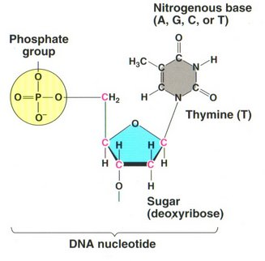

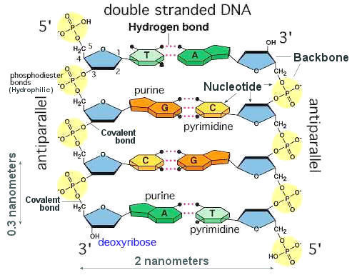

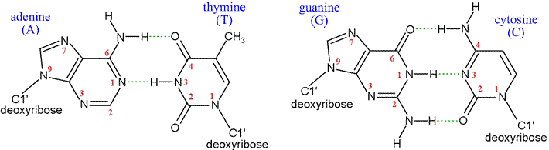

DNA replication
- Recall the S phase of the cell cycle where “DNA replicates.” This is that process.

- DNA replication: is the process of producing two identical replicas from one original DNA molecule.

- This is a complex process that occurs in the nucleus. It involves many enzymes.

- I will provide you with a trimmed down version of the process involving a few of the enzymes.

Step 1: The DNA “unzips” by breaking the hydrogen bonds between the bases in a pair. At the same time the double helix is unwound. The enzyme helicase does these tasks.
Step 2: the separated base pairs are quickly paired back up with the appropriate bases on new nucleotides that come into the nucleus from the cytoplasm.
Step 3: Each new strand of DNA is replicated in a different manner. Best explained by an animation. Ill post on the website.
Step 4: Once replication is complete you have 2 identical strands of double stranded DNA identical to the original.

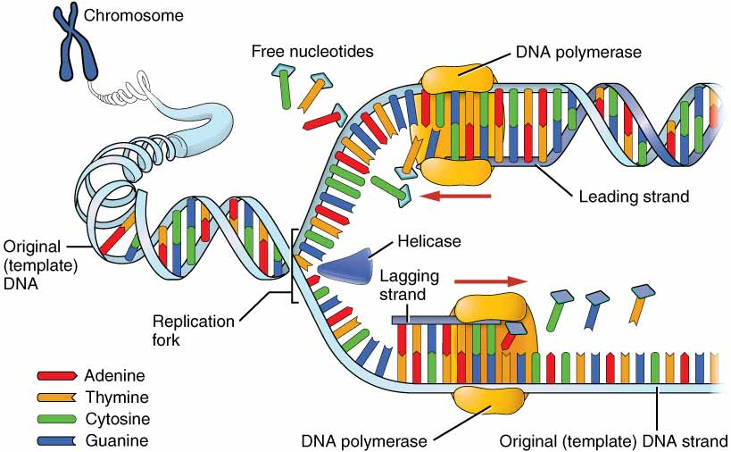

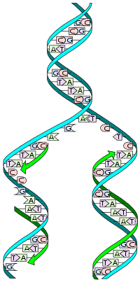

Mutations
- Sometimes mistakes are made copying DNA during replication and during transcription
- DNA polymerase checks itself for errors
- Sometimes errors aren’t corrected properly and this “mistake” or mutation becomes part of that organisms DNA
- Types of mutations:
  - POINT MUTATIONS: a single base pair is different.
    - Substitutions- one base is substituted for another
    - Insertions- an extra base is inserted into the sequence
    - Deletions- a based is removed from the sequence
- Insertions and deletions cause frameshifts.
- Insertions causes the frame to shift to the right or downstream.
- Deletions causes the frame to shift to the left or upstream.
- Frameshifts usually affect al amino acids from the point onward.
- Can cause different amino acids to be used or premature STOP signals.

