Earth Science: Chapter 2: Climate change and weather Notes
LT 2.1 I can distinguish between weather and climate.
Weather is the state of the atmosphere in a particular place and time.
Climate- long-term variation in weather in a certain area.
Climate is usually averaged over a 30+ year period.

LT 2.2 I can explain climate system and how it affects our weather.
Weather occurs over short time periods. The weather predictions usually cover days or weeks.
Weather is an expression of the climate system.
The climate system is the interaction of the atmosphere, biosphere, geosphere, and oceans that determines weather at a time or place.
Atmosphere- the air surrounding the earth up to the edge of space
Biosphere- any part of earth where life is found
Geosphere- the physical rocky surface and other layers of the earth.
Hydrosphere- all the water on earth. Includes the ice as well (the cryosphere)
The climate system is important because:
- The climate system determines the weather. The weather affects many of our daily decisions.
- Climate affects long-term decisions by humans.
- Climate affects long-term trends in plants and animals.
When you hear the word “weather” what do you think of? List at least 3 words associated with weather; more if you can
______________________________
______________________________
______________________________

LT 2.3 I can use geography and knowledge of the North American air masses to help explain how certain areas have the climate they do.
Air mass- A large body of air that take on the characteristics of the area over which it forms. The region it forms is called the source region.

Classifying air masses: According to their source region:
Continental tropical(cT)- warm/dry Cold and humid maritime polar(mP)
Maritime tropical(mT)- warm/humid Arctic (A)- same as cP but much colder
Cold and dry Continental polar(cP)
Source regions for North America
mP- north Atlantic, and North Pacific cP- interior of Canada and Alaska
mT- Caribbean sea, and gulf of Mexico cT- Desert SW of U.S. and Mexico
A- Siberia and Artic basin

Air mass modification: Air masses don’t stay in one place. They move and transfer energy(heat). They move over an area that has different characteristics than its own. So they acquire some of the characteristics of the new surface beneath them.
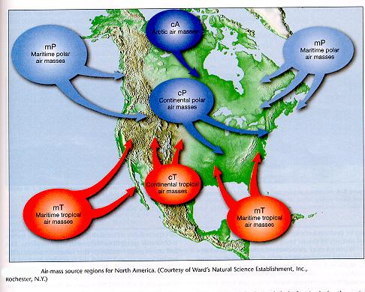

- What type of air mass influences Louisiana’s weather? _________________________________
- What type of air mass influences Washington state’s weather? ___________________________

LT 2.4 I can use basic weather instruments to measure the current condition of the atmosphere.
Complete what each of the following weather instruments measure.
Thermometer- Scales used:
Barometer- units used:
Anemometer-
Sling psychrometer-
Wind vane-

LT 2.5 I can explain what happens when sunlight interacts with the atmosphere and the surface of the earth.
In my own words, energy means . . . . .

In my own words, an example of a budget is . . . .

In my own words, equilibrium means . . .

What is the source of energy that drives climate?

In my own words, albedo means . . .

When a surface has a high albedo, is the amount of sunlight reflected high or low?

How much of the sunlight is reflected?

What happens to the incoming solar energy? 1368 watts/meter² of energy reaches the top of the atmosphere. Here is a breakdown of what happens to it.
- Reflected by clouds= _______%
- Reflected by the atmosphere= _______%
- Absorbed by water vapor, dust, and ozone in the atmosphere= _______%
- Absorbed by clouds= _______%
- Reflected by the earth’s surface back into space= _______%
- Absorbed by the earth’s surface(land, structures, and oceans)= _______%
Remember that budgets have an income and an outgo, so the earth also releases the temporarily stored energy that was on the incoming side. Here is what happens to the released energy.
- Conduction and rising air= _______%
- Radiated to space by clouds and atmosphere = _______%
- Solid surfaces radiate heat=_______%
- Evaporation of heat from bodies of water=_______%
Conduction-
Convection
Radiation

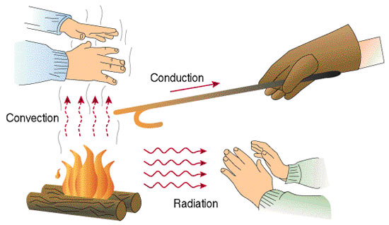
Radiation:
- When energy is absorbed by an object (rock, water, building), the temperature of the object increases.
- All objects emit radiation. The amount and wavelength range is dependent on the temperature of the object.
- As the temperature increases (hotter), the wavelengths emitted by the object decreases (becomes shorter wavelengths).
- Earth absorbs and re-radiates energy
- In Earth’s Energy Budget, all of Earth is considered together
- Air (Atmosphere) Land (Lithosphere) Ice (Cryosphere) Ocean/Water (Hydrosphere) Life (Biosphere)

Convection: Transfer of heat by the movement of a heated fluid. Gases and liquids are considered fluids.
Conduction: Heat transfer through direct contact (touch) of molecules.

LT 2.6 Be able to explain why the structure of some waves cause them to have certain amounts of energy.
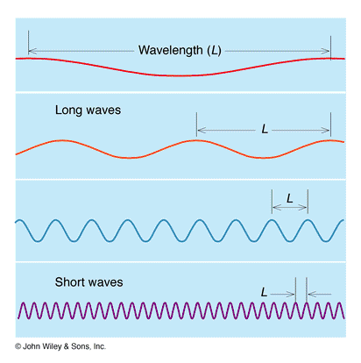
Electromagnetic (EM) wave: are formed from an interaction of an electric field and magnetic field. They can travel in the vacuum of space unlike mechanical waves.
Parts of a wave:

Question: What characteristic of the 4 waves above is different in each wave? _________________
Can you identify any other differences?
Question: What causes some waves to have more or less energy than other waves?
Task: Identify 3 ways that electromagnetic (EM) waves play a role in your life.

Waves that have short wavelengths have high frequencies and more energy than waves with lower frequencies.
Solar radiation comes to earth in ___________________ waves.
Heat escaping earth back into space has ____________________waves.

LT 2.7 I can identify greenhouse gases, their sources, and how they work to cause the greenhouse effect.
Name of greenhouse gas | Chemical Formula | Source
Carbon Dioxide

Methane

Water (vapor)

Nitrous oxide

Sulfur dioxide

Chlorofluorocarbons

LT 2.8 Be able to discuss the effects of climate change on physical and living systems
1. Global warming: Average temperature of the earth (land and oceans) over time slowly. Greenhouse effect is responsible. Record high levels of some greenhouse gases like CO₂. Current CO₂ levels are over 400 ppm (parts per million) this could melt polar land ice (glaciers) and send excess liquid water into the oceans flooding coastal areas worldwide.
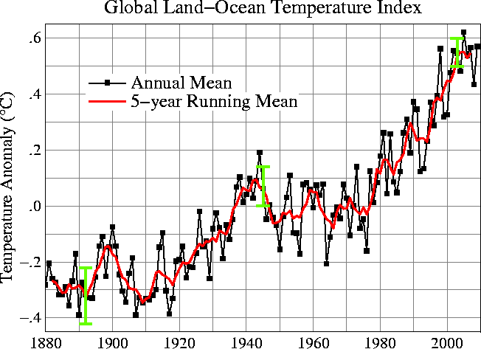
2. Ocean Acidification: “The other carbon dioxide problem”; atmospheric CO₂ being converted to carbonic acid in the oceans. This lowers the pH of the ocean water causing damage to living systems. It interferes with oyster reproduction. Low pH also prevents corals from growing. Coral reefs are MAJOR habitats for many marine species.
3. Changing weather patterns: numbers and strengths of tropical storms are increasing over time. Some areas of the US are experiencing greater than average number of days with heavy rain. With climate change more severe droughts are expected to occur.
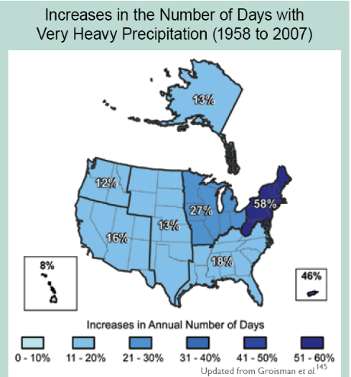
LT2.9: I can explain the correlation between temperature increases and CO₂ levels over time.
Scientists study ice cores drilled out of Antarctica ice. These ice cores are like studying tree rings. They can “look” back in time 60,000+ years and determine the amount of CO₂ in the atmosphere as well as temperatures, and even what types of pollen was in the air at the time the ice formed.

They have learned that CO₂ levels have risen and fallen (as have temperatures) many times in earth’s history, but CO₂ levels have never been this high(currently over 400 parts per million (ppm)
