Biology
A. Ward

Chemistry Review
Atom-the basic unit of matter

The subatomic particles that make up atoms are protons, neutrons, and electrons.

The mass of the proton and neutron are about equal. However, the mass of the electron is much smaller in comparison

Protons-found in the nucleus of an atom and carries a positive charge.

Neutron-found in the nucleus of an atom and does not carry a charge.

Electron-found in the energy level outside the nucleus and has a negative charge that is equal and opposite to that of the proton.

The atomic number of an atom is equal to the number of protons. The atom must be neutral so the number of protons in the nucleus must equal and be opposite in charge to the number of electrons outside the nucleus.

So the net charge of a neutral atom must be zero.

Mass Number=Protons plus neutrons

How do we recognize an element in a chemical equation? Elements are pure substance that consists entirely of one type of atom. Elements are represented by one letter or two. If two letters are used, the second letter is never an upper case letter.
Depending on the number of electrons, atoms can have up to seven energy levels-also called orbitals or electron cloud. Each level can hold the following numbers of electron:
1st Energy Level-2 electrons
2nd Energy Level-8 electrons
3rd Energy Level-18 electrons
4th Energy Level-32 electrons
Electrons tend to occupy the lowest energy level available.

For example, aluminum has 13 protons and 13 electrons. Two electrons will be in the first energy level; 8 electrons will occupy the second energy level; 3 Electrons will occupy the third energy level and this level will not be filled.

The most important energy level when determining the properties of an atom is the outermost energy. The number of electrons in the outermost energy level are called valence electrons and they determine the chemical behavior of the elements.

Describe the difference between ions and atoms and the importance of ions in biological process.

Atoms vs. Ions

An Atom is the smallest unit of matter.

Ions- Atoms that has gained or lost electrons therefore the number of protons and the electrons are not equal. Ions would therefore have either a positive or negative charge.

When an ion has more protons than electrons they are called cations because they take on a positive charge. When an ion gains more electrons than it has protons, they are called anions because they take on a negative charge.

Comparison of Atom and Ion
Atom | Ion
Smallest and indivisible unit of matter | An atom with an electrical charge
Number of protons and electrons are equal | Number of protons and electrons are unequal
Can take part in a chemical reaction | Cannot take part in chemical reaction
May or may not be able to exist independently | Exist independently in solution
Generally unstable | Stable
Not always soluble in blood or body fluids | Soluble in blood and body fluids; This is very important to living things!
Compare the types of bonding between atoms to form molecules.

Chemical compound-a substance formed by the chemical combination of two or more atoms.
Chemical compounds are represented by a chemical formula that includes a subscript.

Chemical Bond-the way that atoms are held together. The type of bond is also determined by the valence electrons involved.

The role of bonding in energy production is simple: When chemical bonds are formed, energy is stored. When chemical bonds are broken, energy is released. The stronger the bond, the more energy is released when the bond is broken.

There are 3 types of Chemical Bonds:

Strongest______________________________>Weakest

Ionic Covalent Hydrogen

- Ionic Bond-formed when one or more electrons are transferred from one atom to another.
Ionic bonds are the strongest bonds that form between the positive and negative attraction of metals and nonmetals.

- Covalent Bond-forms when electrons are shared between atoms. The compounds that are held together by a covalent bond are called Molecules. Forms between two nonmetals
Form between two non-metals from the right side of the stair-step. Water (H2O) is a covalent molecule
3. Hydrogen Bond-Weak bond that forms between a hydrogen atom in one molecule and an extremely electronegative atom. In biology, we will limit our study to the hydrogen bonding of the water molecule. The hydrogen atom of the water molecule is attracted to a negative oxygen region of another water molecule. This results in POLARITY!

How are chemical reactions represented by chemical formula.

Chemical Reaction-a process that changes one set of chemicals into another set of chemicals

Reactants-the elements or compounds that enter into the reaction

Products-The Elements or Compounds produced by the chemical reaction

Coefficient-the number in front of the formula. Just as in algebra, the numeral 1 is not usually written.

Subscript-the number of atoms of that kind that make up a substance; Subscripts cannot be changed in a chemical reaction. Doing so would change the compound represented

Chemical reactions always involve the breaking of bonds and the formation of new bonds

Energy in Reactions-Energy is always released or absorbed whenever chemical bonds are broken or formed.

Explain the difference between organic and inorganic compounds.

Organic compound-the study of chemical compounds that contain carbon atoms. All living things MUST contain carbon!!

Molecules containing carbon are called organic molecules and those that do not are called inorganic.

Explain the fundamental principles of the pH Scale and the consequences of having the different concentrations of hydrogen and hydroxide ions.

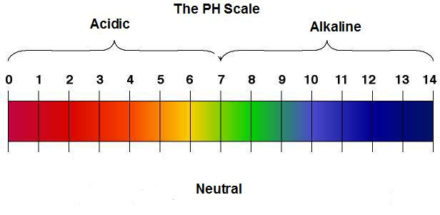
PH Scale-A scale devised by scientists to show the concentration of H+ ions in solution. The scale runs from 0 acid –14 base. 7 is neutral while 0 is the most acidic and 14 is the most alkaline.

Pure water has a pH of 7. This is neutral. There is an equal number of hydronium (hydrogen) and hydroxide ions in water.

Acid-any compounds that forms hydrogen ions (hydronium) (H+) in solution. Acidic solutions contain hi

**If hydronium ions are added to a solution, the pH of the solution will be lower. If hydroxide ions are added to a solution, it will become more basic/alkaline and the pH will rise.
Adding more hydrogen ions (H+) in makes a solution more acidic. Acidic solutions have pH values of lower than 7.
Adding more hydroxide ions (OH-) in solution makes it basic or alkaline. Bases contain lower concentrations of H+ ions than pure water and have pH values of above 7.

Base-any compounds that forms hydroxide ions (OH-) in solution. Basic or alkaline solutions contain lower concentrations of H+ ions than pure water and have pH values of above 7.

Controlling pH is important to maintain homeostasis

Buffers-weak acids or bases that can react with strong acids or bases to prevent sharp, sudden changes in pH. Buffers are also important to maintain homeostasis!

Begin Section 2-TBL#2 Macromolecules of Life

Important Properties of Water

Water is important because it provides an aqueous environment for all the chemical reactions in living things to take place. Important properties of water:

1. Polarity makes water a GREAT SOLVENT! The effect of Polarity produces an attraction of polar molecules to other molecules like them (Ex. One water drop is attracted to another water drop). Everything dissolves in water but oils!!

2. Surface tension or water molecules cause cohesion which help plants pull water up from the ground by the root and allow water to flow up the stem! (Like the pennies)

Elements of Life

Facts:

- 99% of all living tissue is made from only 6 elements: SPONCH (SULFUR, PHOSPHORUS, OXYGEN NITROGEN, CARBON, HYDROGEN)
- Carbon is especially important because it had 4 Valence Electrons so it can form a covalent bond with 4 other atoms at one time.
- Carbon can bond to other carbon atoms that gives it the ability to form chains that are of unlimited length
- Carbon-carbon bonds can be single, double, or triple covalent bonds
- Chains of carbon atoms can close to form a ring among itself.
- Carbon is the most versatile of elements in forming compound structures
Macromolecules-giant molecules formed from thousands of smaller molecules

Polymerization-process of formation of macromolecules by putting together smaller molecules

How are monomer units joined together? The process is called Dehydration Synthesis. 2 monomers are linked together and an H2O molecule is squeezed out. To join 20 monomers together, 19 H2O molecules will be produced!

Hydrolysis-If a water molecule is added, 2 monomer units can be pulled apart. (Lysis means to split)

Monomers-single compound units

Polymers-large compound units formed from many monomer units

4 Macromolecules Needed for Living Things. Each of these is a polymer (long repeating chain) of monomers:

- Carbohydrates-Used to provide the main source of energy or food to living things. They also give big structure like cellulose in a plant.

Made Up of: Elements carbon, hydrogen, and oxygen. 1 part carbon to 2 parts hydrogen to 1 part oxygen atoms. 1 carbon will have a C=O and all other carbons will be attached to a hydroxyl group (OH)

How do I recognize a carbohydrate? Look for a ring structure and primarily carbon, hydrogen, and oxygen if in solution. Crystalline forms of most monosaccharides will be a long-chain structure. In living cells, carbohydrates are always in solution and appear in a ring.
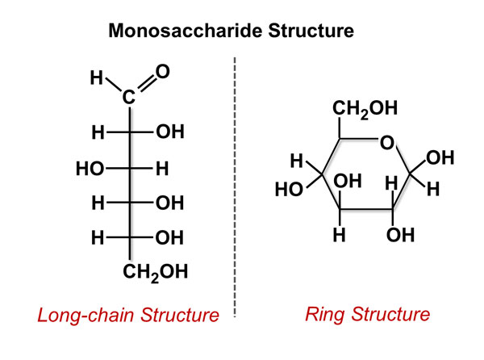
Examples of Carbohydrates

Monosaccharides-simple sugar molecules (glucose, lactose, fructose)
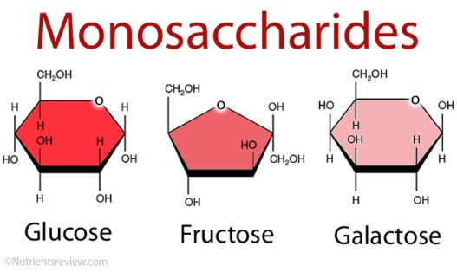

Disaccharides-made of two carbohydrates joined together

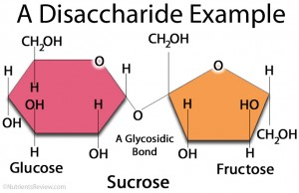

Polysaccharide-large sugar molecules that are made up of many monosaccharides linked together
Ex. glycogen in animals and cellulose in plants. Polysaccharides is the way that most excess sugar is stored in both plants and animals

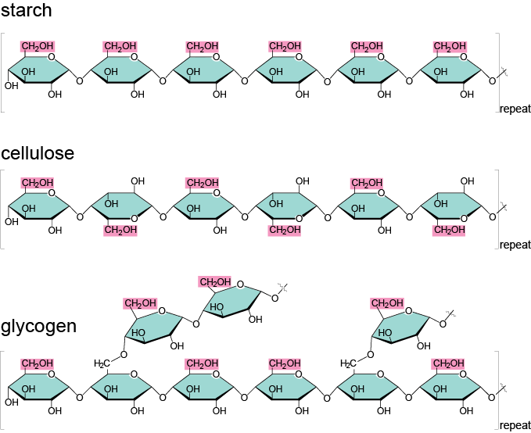

Lipids- Lipids are larges molecule made up of carbon and hydrogen atoms. They are usually not soluble in water (saturated and unsaturated fats and steroids are lipids).
Lipids also can provide some energy for living things but not as much as carbohydrates.

Glycerol and glyceride are major components of Lipids.

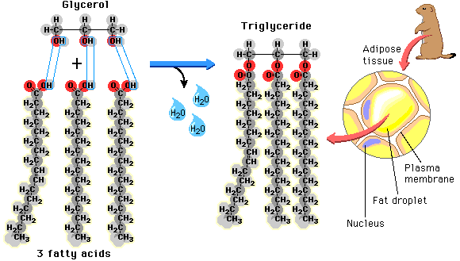

Recognizing Examples of Lipids.

Saturated Fats-contains the maximum number of hydrogen atoms that a carbon chain can have; usually solids at room temperature

Unsaturated fats-do not contains the maximum number of hydrogen atoms; if the molecule contains at least one carbon-carbon double bond, it will be unsaturated. Almost all unsaturated fats are liquids at room temperature.

Polyunsaturated fats-contain at least 2 or more double bonds between carbons.

Steroids are a lipids, too. Cholesterol is a steroid made by living things.
Steroids
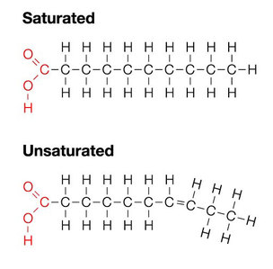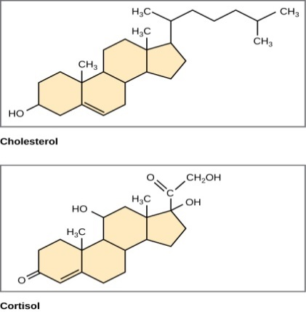
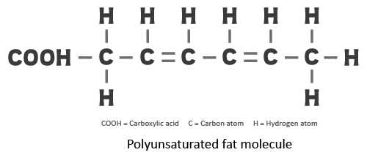

Lipids give us structure because all cell membranes are made of lipids called phospholipid bilayer.

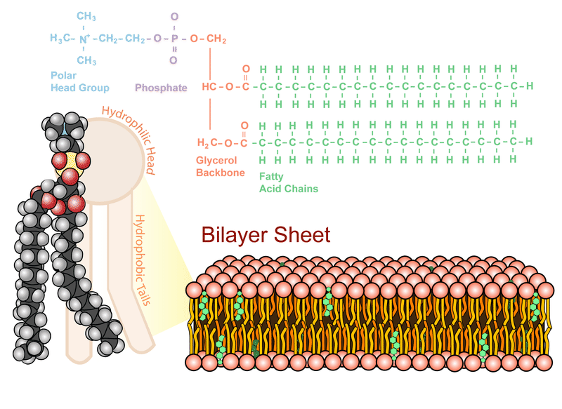
- Nucleic Acids-The common names of nucleic acids are DNA and RNA which are responsible for the information inside the cell. Nucleic acids are composed of carbon, hydrogen, nitrogen, and MUST contain phosphorous. DNA and RNA are the only biological molecules that contain phosphorous!
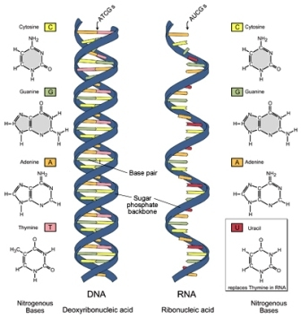

DNA in eukaryotic cells is found in the nucleus. The segments along DNA are called genes. Genes are bits of DNA that code for a specific protein.

RNA is responsible for transmitting information out into the cell. Genes are translated into proteins.

Changes in the DNA will result in changes in the genes which result in changes in the proteins!

What are nucleic acids made up of? Macromolecules (polymers) containing hydrogen, oxygen, nitrogen, carbon, and phosphorous. The other elements are put together in the form of a nucleotide

Nucleotide-consists of 3 parts: a 5-carbon sugar, a phosphate group, and a nitrogenous base

- Proteins-building everything including cells and structures. Proteins are made according to the recipe in the DNA

What are proteins? Macromolecules that contain nitrogen as well as carbon, hydrogen, and oxygen. They are polymers of amino acids that are held together by peptide bond.

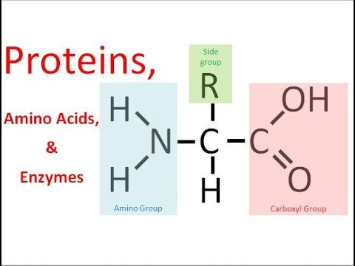

Amino Acids-compounds with an (-NH2) group on one end and a carboxyl group (-COOH) on the other end.

More than 20 different amino acids exist in nature but the –NH2 (amino group) and the COOH (the carboxyl group) are the same in every amino acid

How are amino acids different? The side chain called the R-chain is different. Some R groups are acidic or basic, polar or non-polar. The way they are arranged is pre-determined by the DNA

Proteins are linked by Peptide Bond
a-amino acids; b- dipeptide (two amino acids joined) c-polypeptide (three or more amino acids linked together)
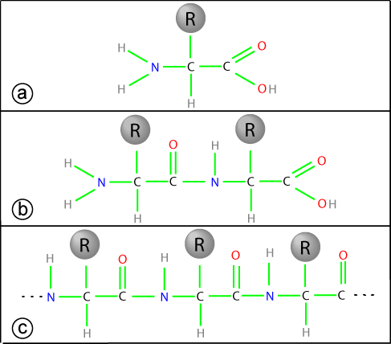

The amino acids make up proteins and each has a specific role. Proteins:

- Control the rate of reactions
- Regular cell Processes
- Form Bones and Muscles
- Transport Substances into or out of a Cell
- Help Fight disease

Levels of Organization of a Protein:
1st Level-Sequence of amino acids in the protein chain

2nd Level-Amino acids within a chain can be twisted or folded

3rd Level-The Chain itself is folded

4th Level-Proteins that have more than one chain have a specific shape and arrangement of the two chains (Van deer Walls Forces control the shape)

Section 3-TBL #3-Enzymes, Feedback Loops, and Homeostasis

Describe the function of enzymes, including how enzyme-substrate specificity works, in biochemical reactions.

Enzymes-proteins that act as a biological catalyst

Catalyst-a substance that speeds up the rate of a chemical reaction by lowering the activation energy required

Enzymes are very specific and catalyze only one type of reaction.

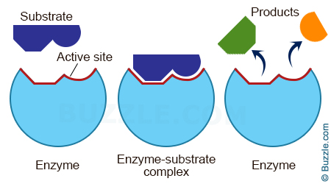
How do enzymes work? For reactions to occur, atoms have to collide with enough energy so that existing bonds are broken and new bonds are formed. Enzymes provide a site where reactants can be brought together to reach maximum yield.

The reactants of enzyme-catalyzed reactions are known as substrates.
Enzymes lower the activation energy it takes for a reaction to occur.

Energy Reactions and Living Things-Why do we need to know about the chemistry?

Activation Energy-the energy that is required to get a reaction started. Slow reactions have activation energies that are extremely high.

Enzymes are important because they lower the activation energy needed to get a reaction started.

How do they lower activation energy?

1. Give orientation or direction to the substrates correctly
2. Weakens the substrate bonds
3. Provides a favorable environment
4. Covalently bonds to the substrate

The effectiveness of enzymes is dependent on:
- Change in temperature
- Change in pH
- Presence of inhibitors
- The Proteins of the cell that are the on/off switch to produce the enzyme. This is critical in making sure that chemical pathway work properly in the body.

The most important chemical reactions the Biology students MUST know are:

Photosynthesis

6CO2 + 6H2O C6H12O6 + 6 O2 (endothermic or endergonic=energy is stored in the bond)

Cellular Respiration - Cells are very good at storing energy. Mitochondria are used to convert glucose into a more useful form called ATP. Called cellular respiration.

C6H12O6 + 6O2 6H2O + 6 CO2 (exothermic or exergonic=energy is released)

Glucose molecule C6H12O6 gives up a lot of energy when broken!

What do we use this free energy for?

Muscle contraction, cellular transport, homeostasis, heat production, photosynthesis, cellular respiration, locomotion, DNA replication and just about any cellular process you can think of!

Fermentation

Glucose + yeast Pyruvic acid Lactic Acid or Ethyl Alcohol

The Energy Molecule-Explain how cells store energy temporarily as ATP.

ADP + Phosphate (P)ATP(energy stored for cells)

ATP is adenosine triphosphate and it serves as the chemical energy supply for all cells. It is made of
• Adenine
• Sugar called ribose
• 2 or 3 phosphates

When the cell needs energy, a phosphate is broken off the ATP to form ADP

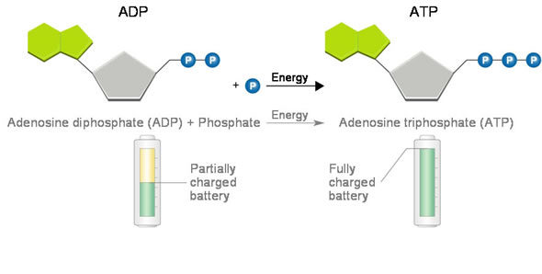

Cellular respiration reaction depicted below:
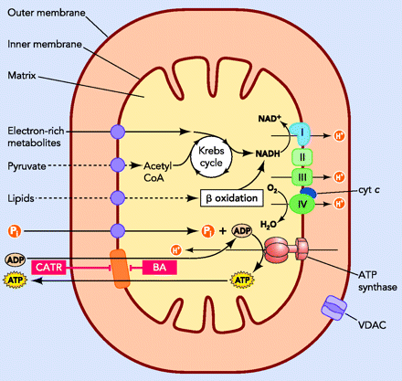
Feedback Loops
200 + Chemical Reactions take place inside the human body every day. Feedback loops are very important to maintain internal homeostasis as your environment changes. There are 2 kinds of feedback loops: positive and negative.

Positive Feedback Loops-These loops help a living thing to move away from a set point. Example: A tree will see all the fruit ripen at the same time because on of the fruits will give off the gas ethylene which diffuses to the other fruits and makes the other fruits ripen. The other fruits then also give off ethylene gas ripening more fruit.

Another example: When your body is invaded like during an staph infection, a positive feedback loop brings more white blood cells to that area.

Negative Feedback Loops-Loops that help a living thing maintain a setpoint. For example, maintaining an internal body temperature of 37 degrees Celsius (98.6F) when your external environment is higher or lower than this is a negative feedback loop. As your body temperature starts to drop in cold weather, we do things like shiver; our blood vessels vasoconstrict or keep our capillaries constricted so blood doesn’t loose heat to the environment and this warms us up. If we get too warm, we vasodilate (open up the capillaries) and we begin to sweat to let go of some heat.

