EARTH SCIENCE – Chapter 5
Formation of the Universe

No scientific theory, law, hypothesis, or idea should ever get in the way of your faith. Likewise, do not look to your religious texts for answer to scientific questions. There is room for both things in the open mind.

LT 5.1 - I CAN distinguish between Theory and Law.
- Theory and Law are words that are interrelated, but NOT interchangeable.
- LAW
  - Statement based on repeated experimental observations.
  - Generalized statement after a number of observations.
  - Laws can usually be boiled down to mathematical equation.
  - Laws are universal. They work the same way in the different places and time.
  - Laws only describe universal observable facts, they do not explain them. So it doesn’t answer “why?”
  - Can be altered in light of new evidence, (but rarely)
Examples of some laws:
- THEORY
  - Well-substantiated explanation of some aspect of the natural world.
  - Explanation of observational data.
  - May be amended, changed, or dismissed as knowledge or new evidence is found.
  - Can become obsolete over time.
  - Can be replaced with more accurate explanations.
  - A theory DOESN’T become a law over time. It explains a law.
  - A scientific theory should never be dismissed as “just a theory”. It’s not a WEAK word.
Examples of some theories:

LT 5.2 - I CAN provide evidence for the Big Bang Theory.
- BIG BANG THEORY
  - Model describing the universe from its earliest known periods through its subsequent large-scale evolution.
  - The universe expanded from a single point that was very high density and high temperature state.
  - The theory is NOT an explosion, but an expansion of space with matter traveling along.
  - After the initial expansion, the universe cooled to allow for the formation of subatomic particles then simple atoms.
    - Protons formed first (almost immediately) and neutrons formed later.
  - Gravity, by way of Stellar Evolution, formed stars and galaxies.
  - Edwin Hubble (1929) concluded that galaxies are drifting apart based on analysis of galactic red shifts.
  - Modern measurements place this moment approximately 13.8 billion years ago.

Misconceptions and realities about the Big Bang theory:
Misconceptions | Realities
No explosion | A continuous expansion
The singularity didn’t appear in space | Space appeared in the singularity

- EVIDENCE
  - FIRST of all, we are reasonably certain that the universe had a beginning.
  - SECOND, galaxies appear to be moving away from us. This is called "Hubble's Law," named after Edwin Hubble (1889-1953) who discovered this phenomenon in 192 9. This observation supports the expansion of the universe and suggests that the universe was once compacted.
  - THIRD, if the universe was initially very, very hot as the Big Bang suggests, we should be able to find some remnant of this heat. This was found to be true in 1965 in which it was discovered that Cosmic Background radiation (CBR) which pervades (spread throughout) the observable universe. This is thought to be the remnant (leftover piece) which scientists were looking for. (Vast regions of empty space occur throughout universe.)
  - FINALLY, the abundance of the "light elements" Hydrogen and Helium found in the observable universe are thought to support the Big Bang model of origins.
  - Cosmic Background Radiation - Weak radiation that is left over from the early, hot stages of the Big Bang expansion of the universe.

LT 5.3 - I CAN discuss the contributions made by Hubble.
- EDWIN HUBBLE
  - In 1929, an American astronomer, established Extragalactic Astronomy when he discovered Cepheid variable stars in the Great Nebula in the Andromeda constellation.
  - Using these stars to measure distance to the nebula, Hubble showed that they were much too far away to be located in our own galaxy.
  - The Andromeda Nebula became known as the Andromeda Galaxy.
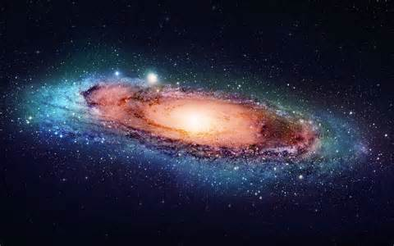

  - Before Hubble, many galaxies were actually misnamed as nebula.
  - Hubble’s Law – explains Recessional Velocity of a galaxy showing its increasing distance from Earth implying an expanding universe.
    - As a galaxy moves further away from us, it travels faster, INCREASING its expanded distance.
  - He clarified that the universe goes far beyond our galaxy – Milky Way Galaxy.
- Hubble’s Contributions
- Determined the Universe is expanding.
- Discovered there were multiple galaxies beyond ours.
- Developed the Galaxy Classification System.
LT 5.4 - I CAN describe the characteristics of Galaxies.
- Hubble classified galaxies based on SHAPE.
  - SPIRAL – disk-like galaxies with spiral arms
    - Barred Spirals – elongated central region (or bar) from which spirals extend
    - Normal Spirals – do not have bars
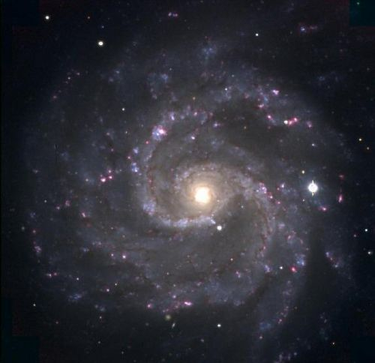 NORMAL SPIRAL 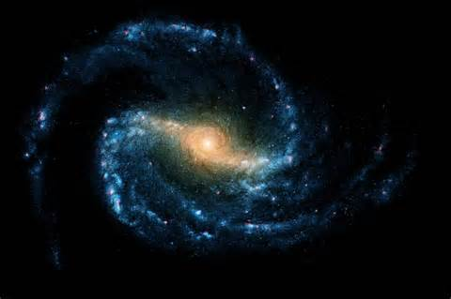 BARRED SPIRAL
    - Barred and Normal can be further subdivided based on how tightly the arms are wound, along with the size and brightness of the nucleus.
  - ELLIPTICAL – galaxies that are not flattened into disks and do not have arms
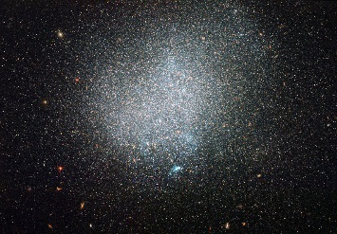
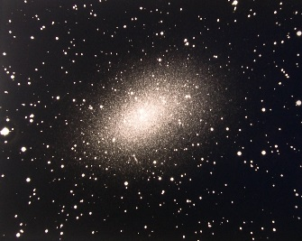
ELLIPTICAL
IRREGULAR

  - IRREGULAR – galaxies that are neither spiral nor elliptical and have irregular shapes
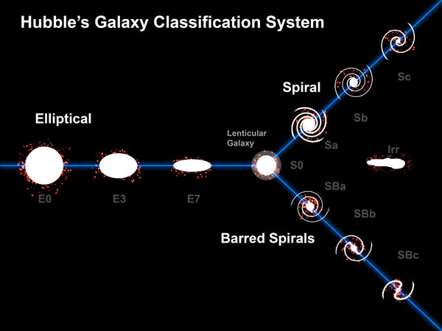

LT 5.5- I CAN explain how the red shift of light from galaxies is used as evidence for expansion of the universe.
- REDSHIFTS
  - Prior to 1929, it was known that most galaxies have REDSHIFTS in their Light Spectra, indicating that all galaxies are moving away from Earth.
- Redshifts happens when light or other electromagnetic radiation from an object is increased in wavelength, or shifted to the red end of the electromagnetic spectrum. In general, whether or not the radiation is within the visible spectrum, "redder" means an increase in wavelength.
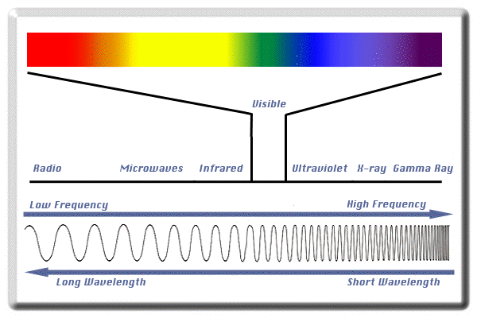
- Hubble measured the redshifts and the distances of many galaxies and found that the redshift of a galaxy depends on its distance from Earth.
- The farther a galaxy is from Earth, the faster it is moving away; THUS the universe is expanding.
- DOPPLER EFFECT
  - Change in pitch or frequency that occurs when the source of a sound wave is moving relative to an observer (coming towards or moving away)
  - Can also be observed in light waves emanated (given off) by moving objects.
  - Astronomers have learned the universe is expanding by observing the Doppler Effect in space.
  - If Doppler is redshift (towards the red end of the electromagnetic spectrum) a star is moving away from us. If Doppler is blue shift (towards the blue end of the spectrum) a star is moving towards us.
Redshift and Doppler Effect
https://www.youtube.com/watch?v=y5tKC3nEx2I
Sheldon Doppler Effect
https://www.youtube.com/watch?v=Tn35SB1_NYI
https://youtu.be/h4OnBYrbCjY

