**Stress**-forces acting on a material: rocks fracture when stress exceeds the strength of the rock.

**Strain**- the deformation of materials (rock) in response to stress.

Undeformed material

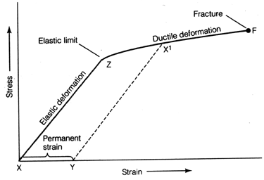

Stress-strain curve

**Fault**-a fracture or system of fractures where movement of rocks occurs.

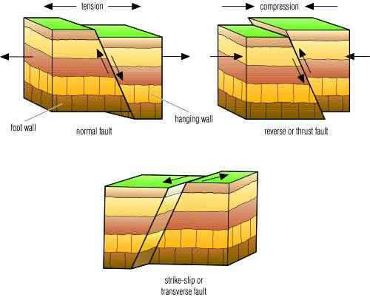

**Low stress** upon an object causes bending (*elastic deformation* phase of the curve) and stretching, but if the stress is removed the material returns to normal.

When stress exceeds a certain value (beyond the elastic limit), the material undergoes **ductile deformation**, a *permanent deformation*. If stress continues, failure of the material will eventually occur (it breaks)

Types of stress:

**Compression-** decrease the volume of the material

**Tension**- pulls the material apart.

**Shear**- causes material to twist.

**Earthquakes** are vibrations of Earth produced by the rapid release of energy.

This energy, which takes the form of waves, radiates in all directions from the earthquake's source, called the **focus**.

*Two* categories of **seismic waves** occur during an earthquake:

1. **surface waves**, which travel along the outer layer of Earth. They move at right angles in 2 directions.
2. **body waves**, which travel through Earth's interior.

There are 2 types of Body Waves:

* **primary**, or **P**, **waves**, which push (compress) and pull (dilate) rocks in the direction the wave is traveling.
* **secondary**, or **S**, **waves**, which "shake" the particles in rock at right angles to their direction of travel.

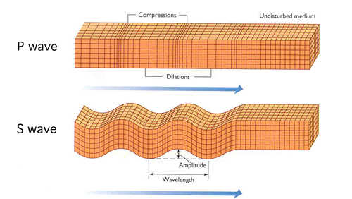

P waves can travel through solids, liquids, and gases. S waves can only travel through solids.

In solids (like rock) P waves travel about 1.7 times faster than S waves.

**epicenter** -- The location on Earth's surface directly above the focus of an earthquakes. The FOCUS is where the earthquake occurred, or where the rock broke.

Section 2: Plotting the epicenter of an earthquake.

Step1: use a seismogram to find the separation time between the arrival of the P waves and arrival of the S waves. S minus P (S-P)

Step 2: Use a travel time graph to locate that S-P value and determine the distance to epicenter.

Step 3: Using the map scale of the map, determine the scale distance and draw a circle around the seismographic station with a radius of that distance.

Step 4 repeat step1-3 for other 2 seismographic stations.

Step: where the 3 circles cross is the epicenter.

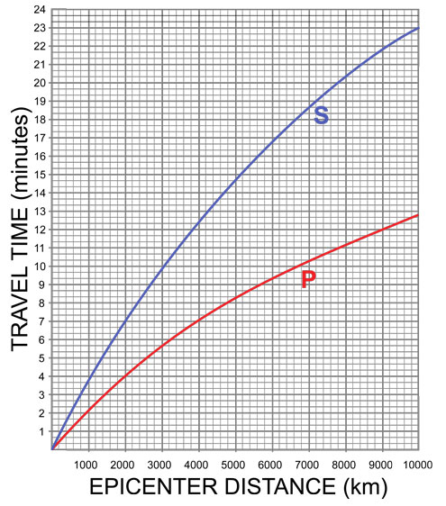

**Travel time graph**: used for finding epicenter distance when you know the difference in p and S wave arrival times.

# Seismometers and seismograms

They can be detected and recorded by sensitive instruments called **Seismometers**.

The record made by a seismometer is a **Seismogram.**

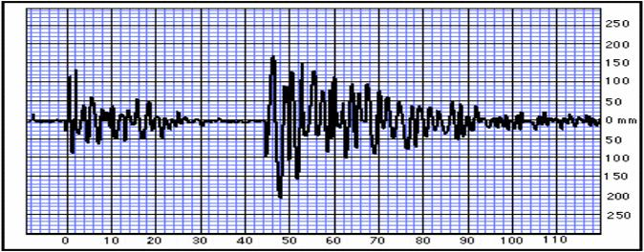

P waves arriving at seismometer

S waves arriving at seismometer

Amplitude- height of the wave. Highest amplitude wave is used in describing the strength of the EQ.

Measuring earthquakes:

**Richter scale—** determinesthe **magnitude** (a measure of the total amount of energy released) of an earthquake. A 1-10 scale. Each unit of Richter magnitude equates to roughly a 30-times energy increase. Example: A 7.0 quake is 30 times more powerful than a 6.0 quake and an 8.0 is almost 1000X (30x30) more powerful than a 6.0 quake.

**Modified Mercalli Intensity scale:** measures intensity of the EQ by measuring the effect (often damage) that the EQ causes.

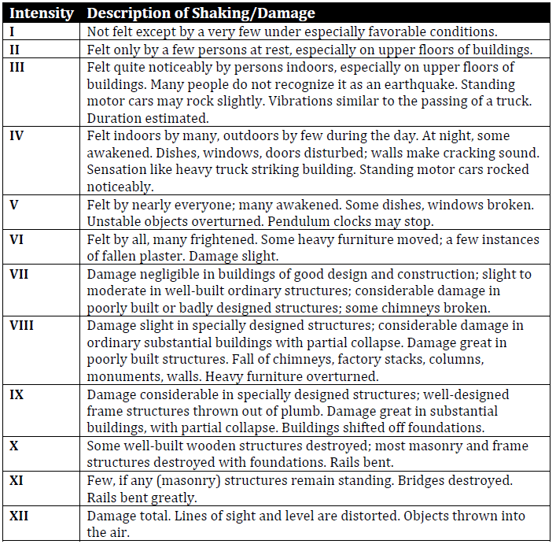

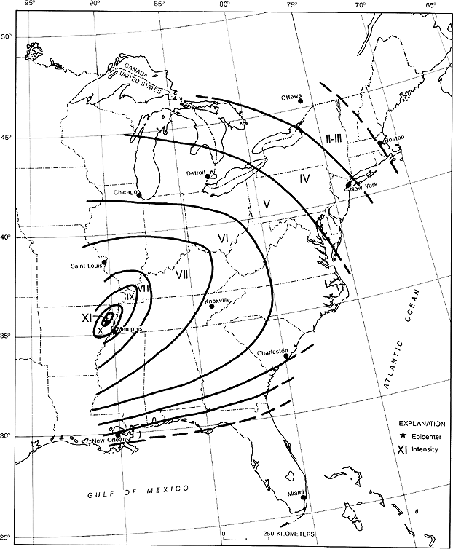

An isoseismic map uses damage analysis of structures and ground to roughly pinpoint the epicenter. Mercalli scale damage ratings are distributed into contours of equal intensity.

The map to the left is the map for the 1811 New Madrid fault earthquake.

Tsunami- a large ocean wave generated during an Earthquake by the vertical movement of the sea floor.

* The motion displaces an entire column of water over the fault.
* Height of wave in the open ocean is only about 1 meter.
* As the wave enters shallow water its height can reach 30+ meters.
* They have open ocean speeds of 500-800 km/hour.

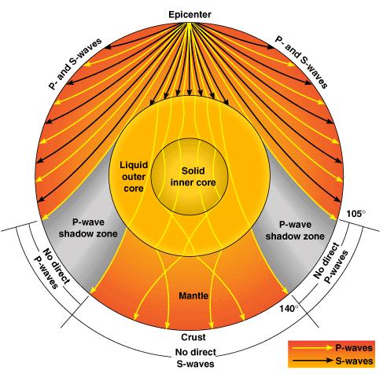

P waves pass through all layers, *but their speed changes at each different layer. This is indicated by the wave lines bending.*

S waves are absorbed by the outer core because it’s liquid.

Scientists theorized, without direct observation, the make-up of the earth’s interior after studying 1000’s of earthquakes, their locations, and their waves.